4x10/100/1000TX+1x1000FX Ethernet Fiber Switch
HT304G-MG1/SG1
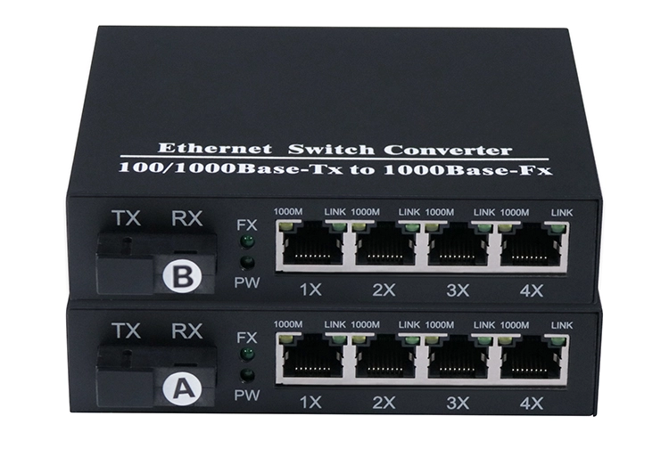
The switch HT304G-MG1/SG1 provides 4-port 10/100/1000M RJ45 and 1-port 1000M 1x9(SC/ST/FC) or SFP fiber ports, user may need to use different SFP modules, such as 1000Base-T, 1000Base-SX, 1000Base-LX and so on.
HT304G-MG1/SG1 switch adopts the latest USA IC, stable performance and excellent quality, with a higher cost performance. For small optical Ethernet and optical network with special needs.

Features
●Complies with IEEE802.3, IEEE802.3u/ab/z standard
●Provides 4-port 10/100/1000M RJ45 and 1-port fiber ports
●Supports auto duplex(HDX/FDX) auto MDI/MDIX function
●Auto MDI/MDI-X support on RJ-45 port
●Supports jumbo frame size 10K bytes
●Status LED for easy monitoring of device status

Specifications:
Model | HT304G-MG1/SG1
Product | Full Gigabit 4+1 Switch
Fixed Port | 4*10/100/1000Base–TX RJ45 port (Data)1*1000M Optical Fiber Port(optional 1310/1550)
Network Protocol | IEEE802.3IEEE802.3i 10BASE-T  IEEE802.3u100BASE-TX  IEEE 802.3ab1000BASE-T  IEEE802.3x  IEEE 802.3z 1000BASE-X
Port Specification | 100/1000BaseT(X) Auto negotiation
Transmission Mode | Store and Forward(full wire-speed)
Backplane Bandwidth | 7.6Gbps
Packet Forwarding | 12.96Mpps
MAC Address | 2K
Buffer | 1Mbit
Switching Delay | <5μs
Transmission Distance | 10BASE-T : Cat3,4,5 UTP(≤250 meter)100BASE-TX : Cat5 or later UTP(150 meter)  1000BASE-TX : Cat6 or later UTP(150 meter)  Available for 1310/1490/1550nm Single mode, 850nm Multi mode  Transfer Distance: up to 120km  Connectors: SC, FC, ST and SFP optional  Fiber core: 9/125μm on single-mode fiber; 50/125μm and 62.5/125μm on multi-mode fiber
Watt | ≤10W;
LED Indicator | PW:Power LEDFX:(Optical fiber LED)  Port :(Green=10/100M LED+Orange=1000M LED)
Power | External power DC 5V 1A
Operating Temperature/Humidity | -10~+60°C;5%~90% RH Non-condensing
Storage Temperature/Humidity | -40~+75°C;5%~95% RH Non-condensing
Product size/Packing size(L*W*H) | 178mm*98mm*25mm
N.W/G.W(kg) | 0.45kg
Installation | Desktop (optional wall hanger+machine hanger parts)
Lightning Protection level | 3KV 8/20us;
Housing | Metal  IP30 protection
Certificate | CE mark, commercial; CE/LVD EN60950;  FCC Part 15 Class B;RoHS;MA;CNAS
Warranty | 2-year

Application
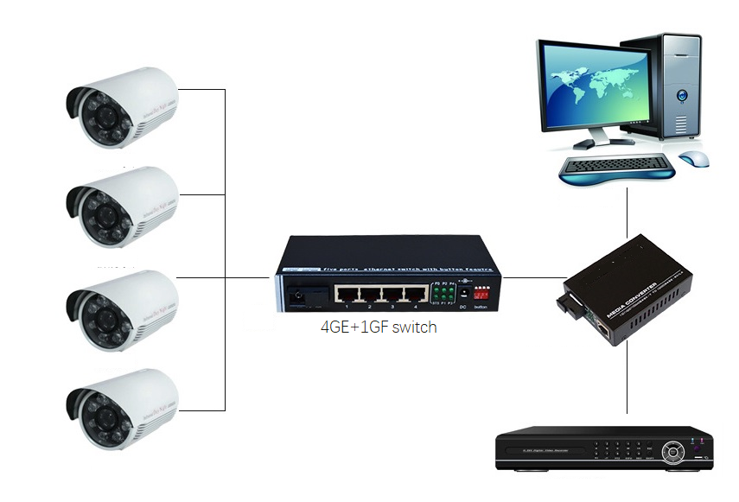
Ordering information
Model No. | Description
HT304G-8M0.5 | 1000Base-Fx to 4*10/100/1000Base-Tx, Multi mode, 0.5Km, SC/ST/FC optional
HT304G-3S20A | 1000Base-Fx to 4*10/100/1000Base-Tx, Single mode, 20Km, SC/ST/FC optional
HT304G-3S40A | 1000Base-Fx to 4*10/100/1000Base-Tx, Single mode, 40Km, SC/ST/FC optional
HT304G-3S80A | 1000Base-Fx to 4*10/100/1000Base-Tx, Single mode, 80Km, SC/ST/FC optional
HT304G-3S20B/5S20B | 1000Base-Fx to 4*10/100/1000Base-Tx, Bi-Directional, 20Km, SC/ST/FC optional
HT304G-3S40B/5S40B | 1000Base-Fx to 4*10/100/1000Base-Tx, Bi-Directional, 40Km, SC/ST/FC optional
HT304G-4S80B/5S80B | 1000Base-Fx to 4*10/100/1000Base-Tx, Bi-Directional, 80Km, SC/ST/FC optional
HT304G-SFPG1 | GE SFP port to 4*10/100/1000Base-Tx

